**Power BI**

**(Hands-on-Assessment)**

Requirement 1: Data Loading

Creating all tables and inserting the values in management studio and then connecting it to sql server.

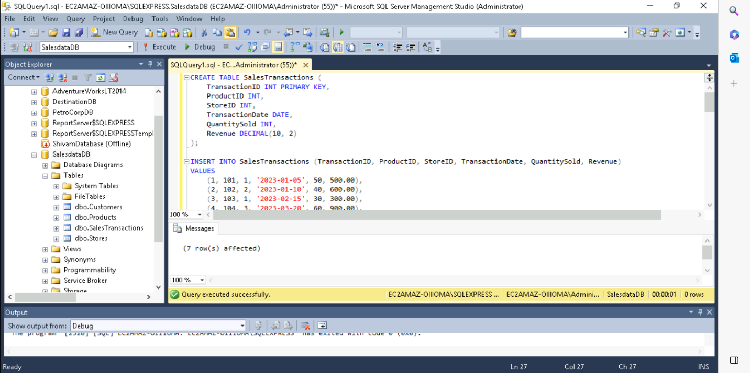

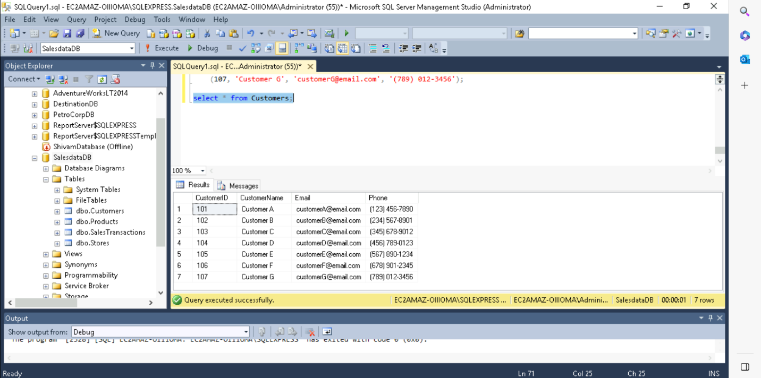

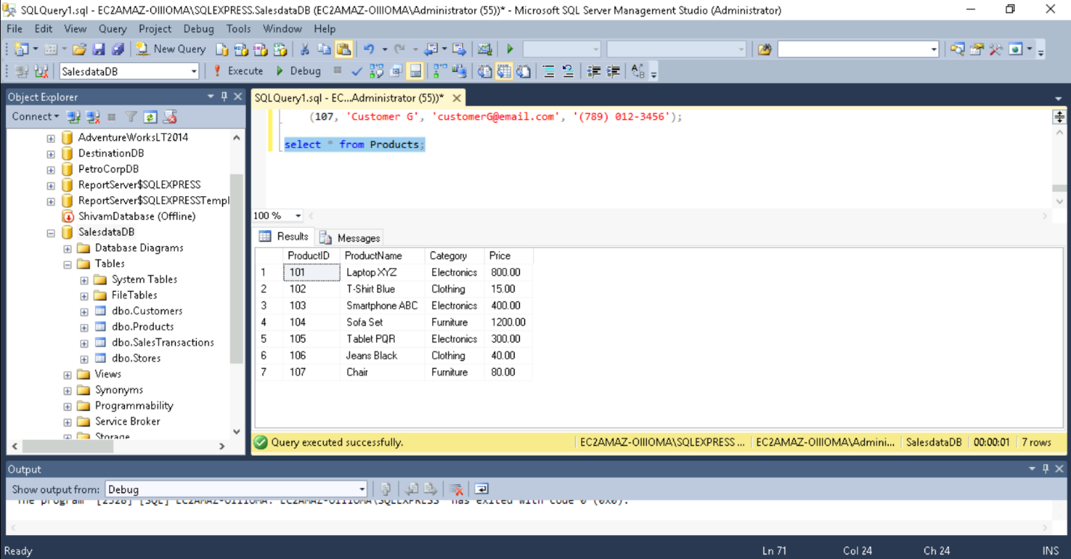

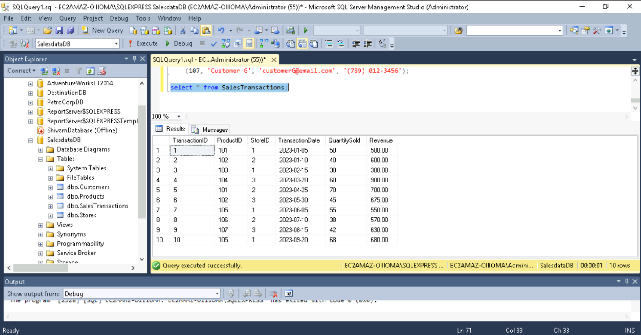

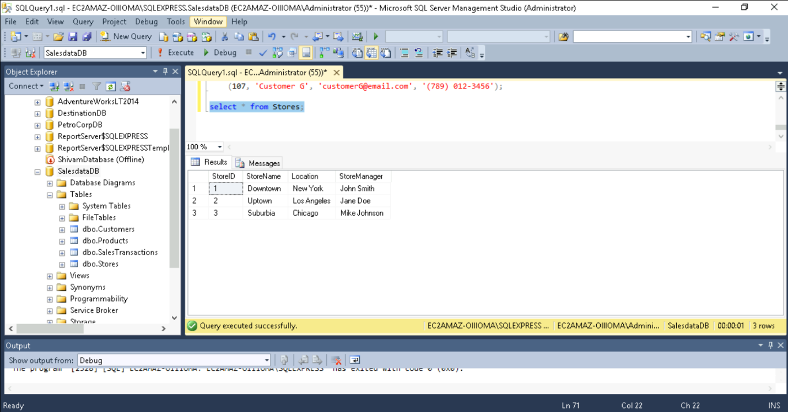

Requirement 2: Data Transformation

• Merge Tables:

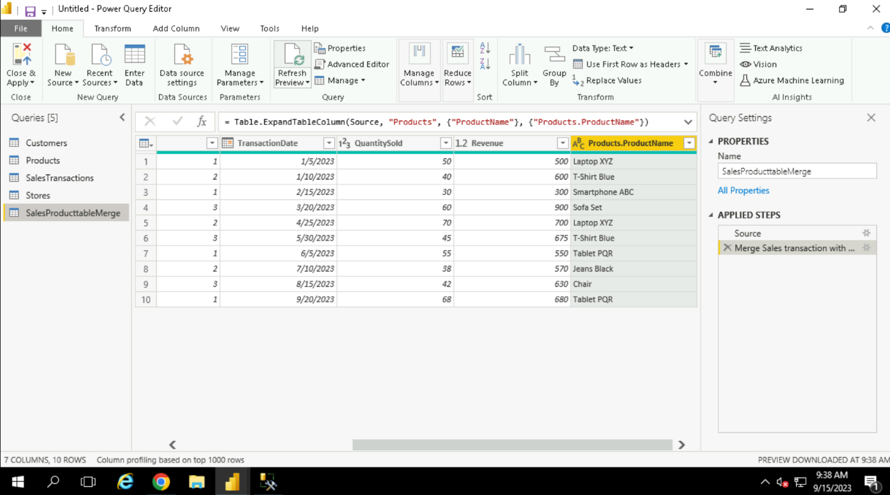

• Clean Data:

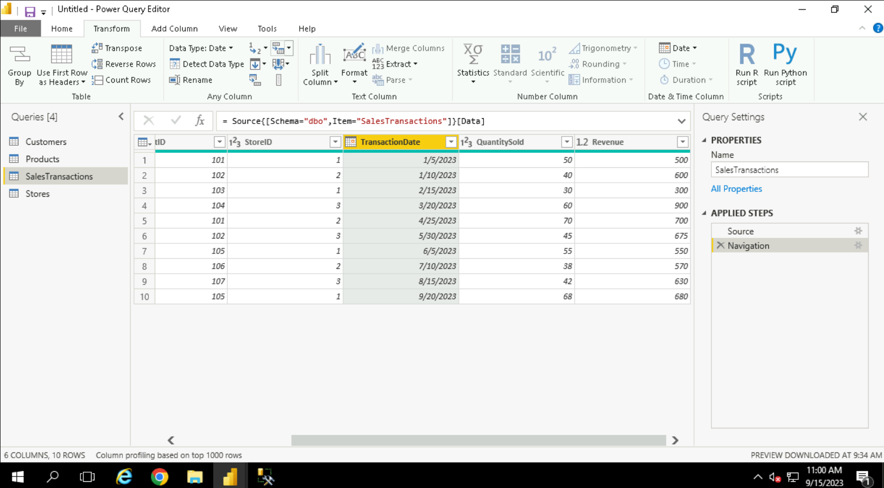

• Filter Data:

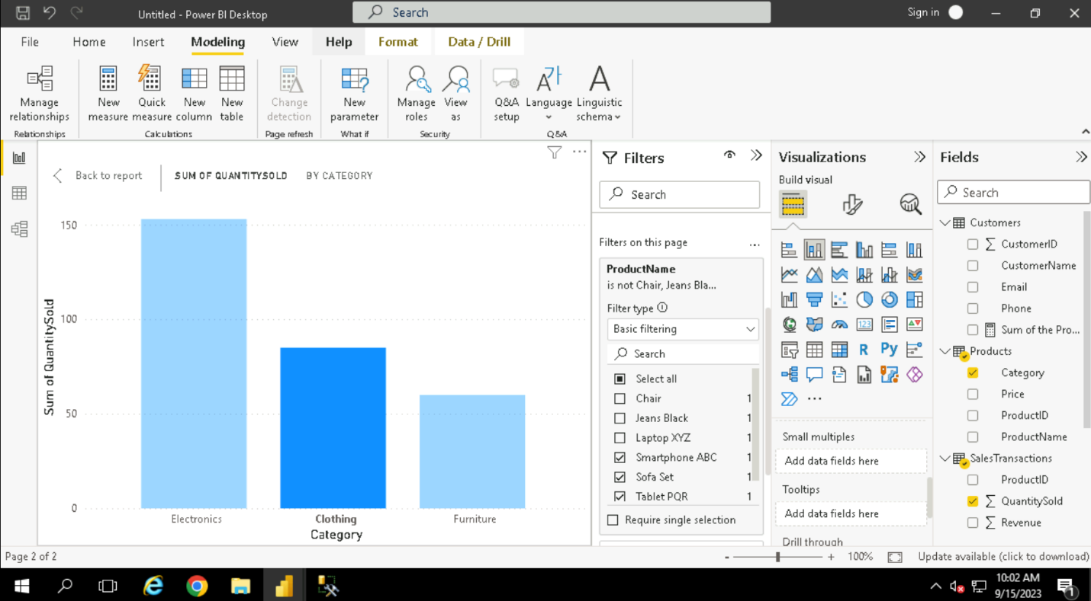

• Create Calculated Columns:

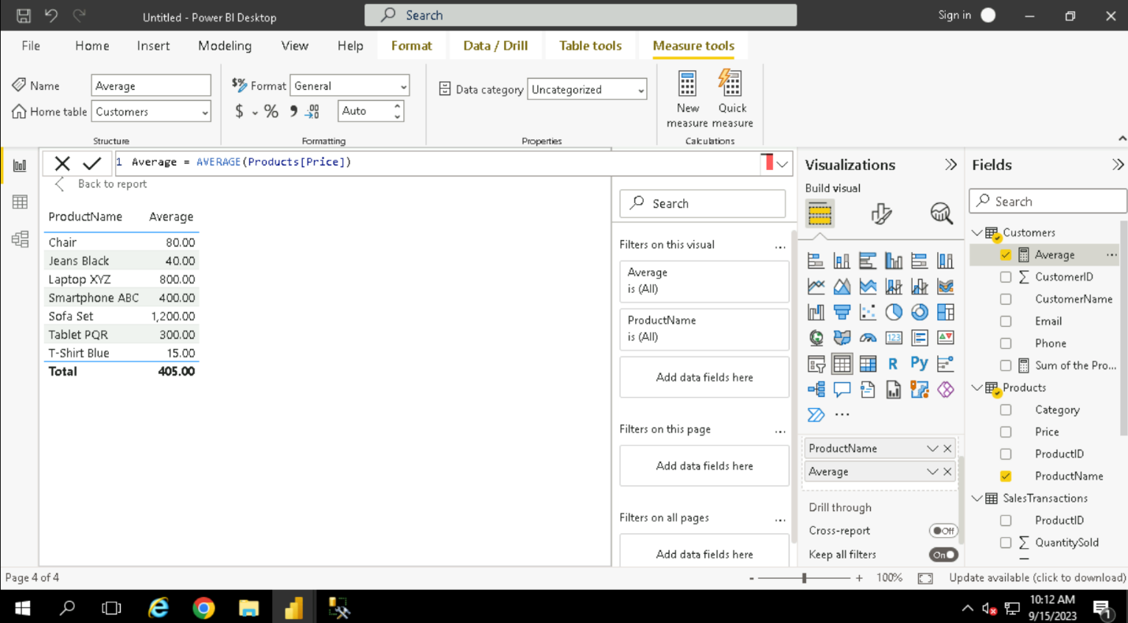

Requirement 3: Data Modelling

• Create Relationships:

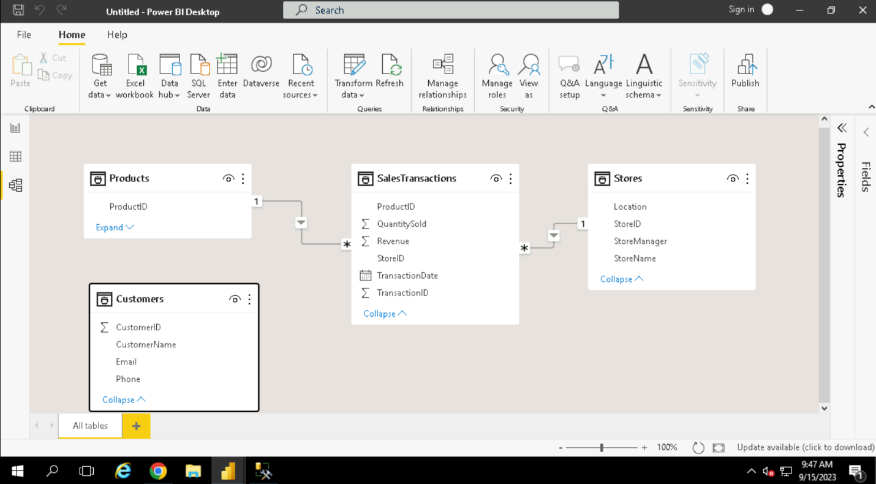

• Create Hierarchies:

Created year hierarchy on the bottom-right of the screenshot.

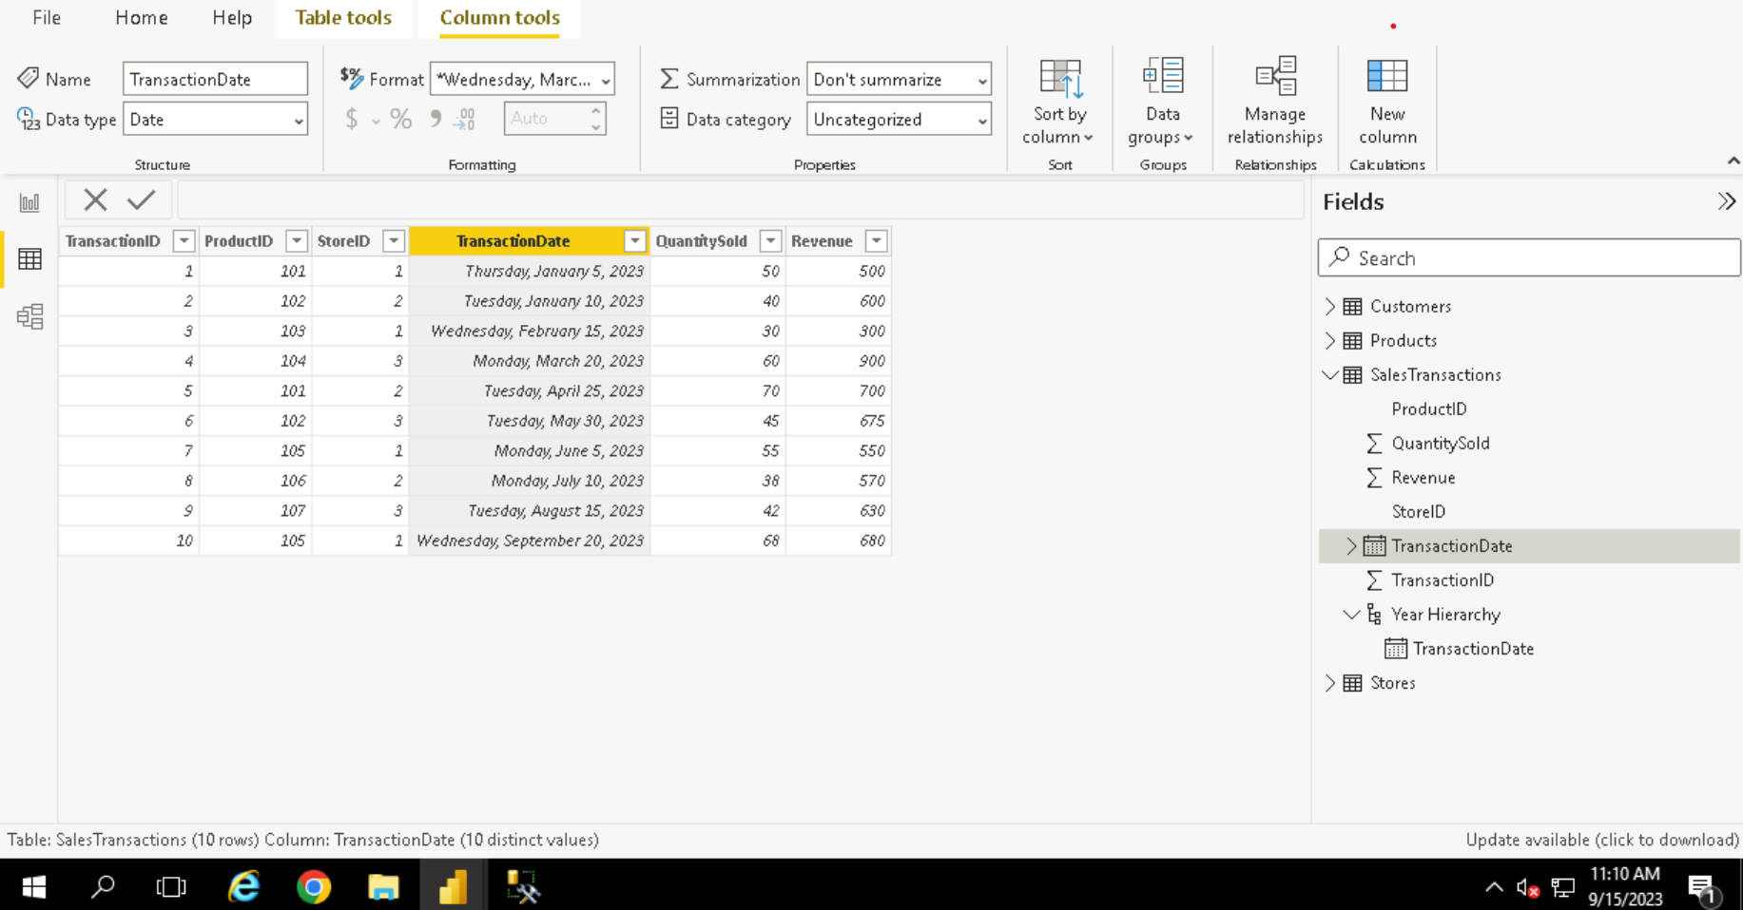

Requirement 4: Business Queries and Analysis

How is sales revenue distributed among different store managers?

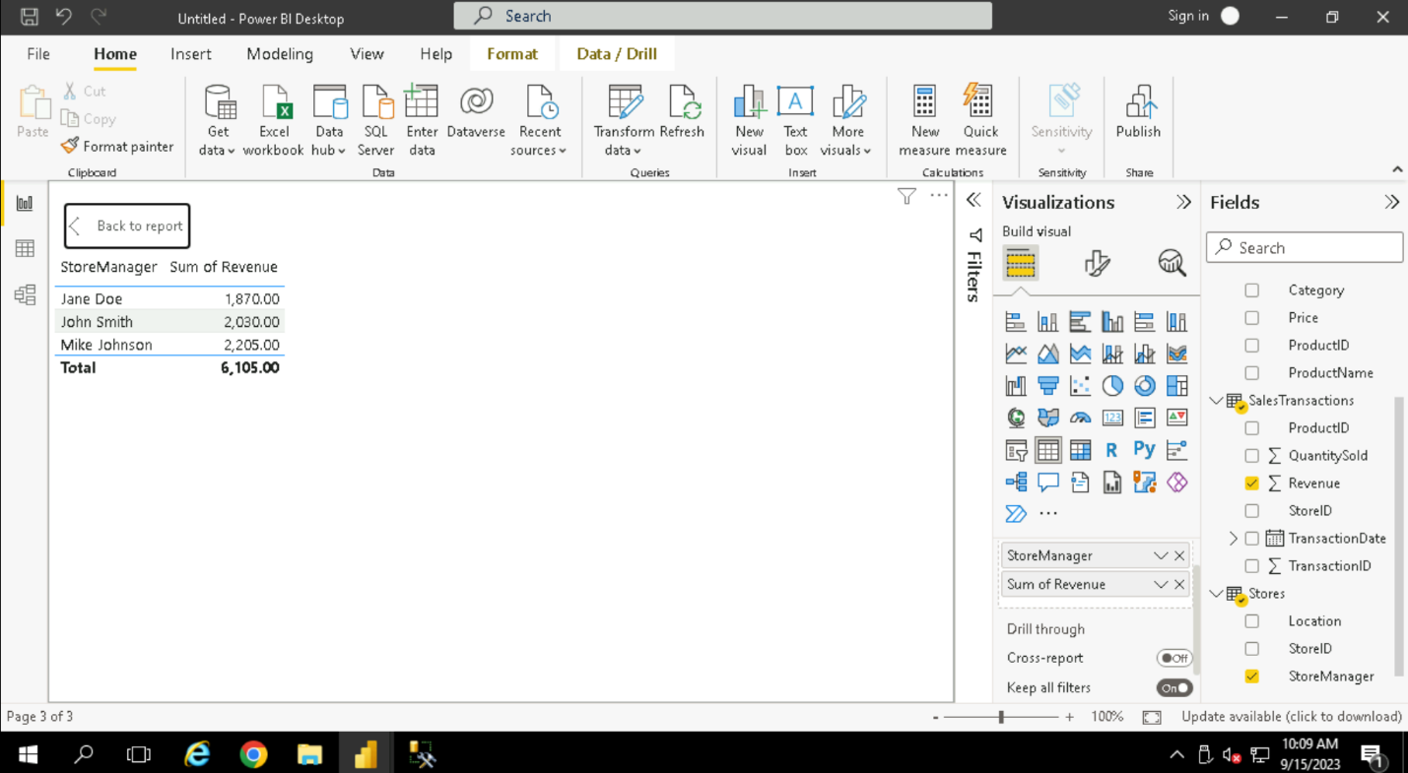

What is the average price of products in each category?

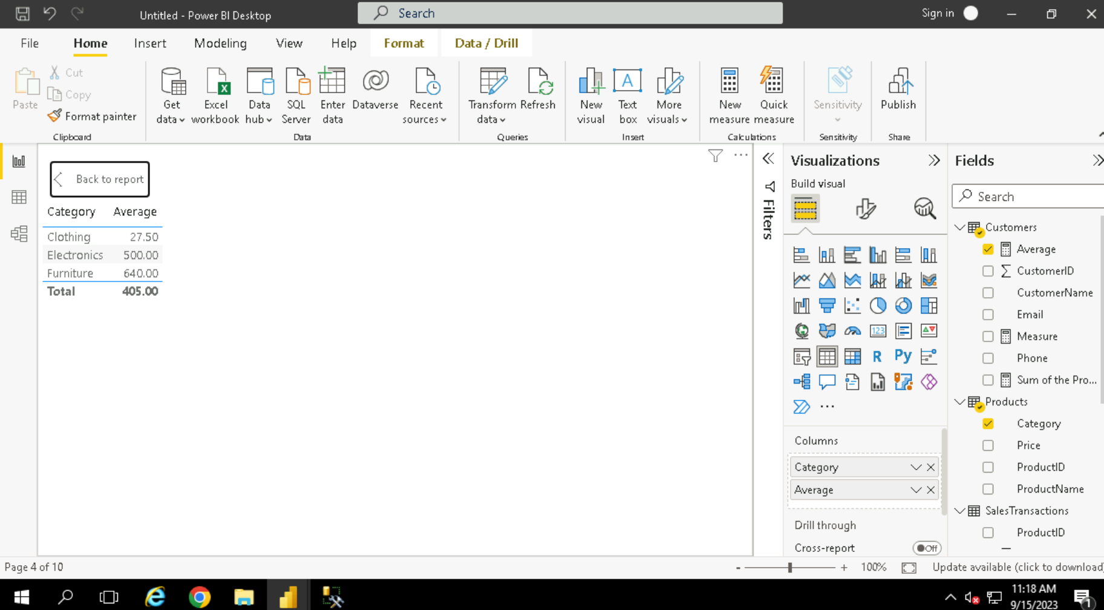



Are there specific days of the week when sales are higher?

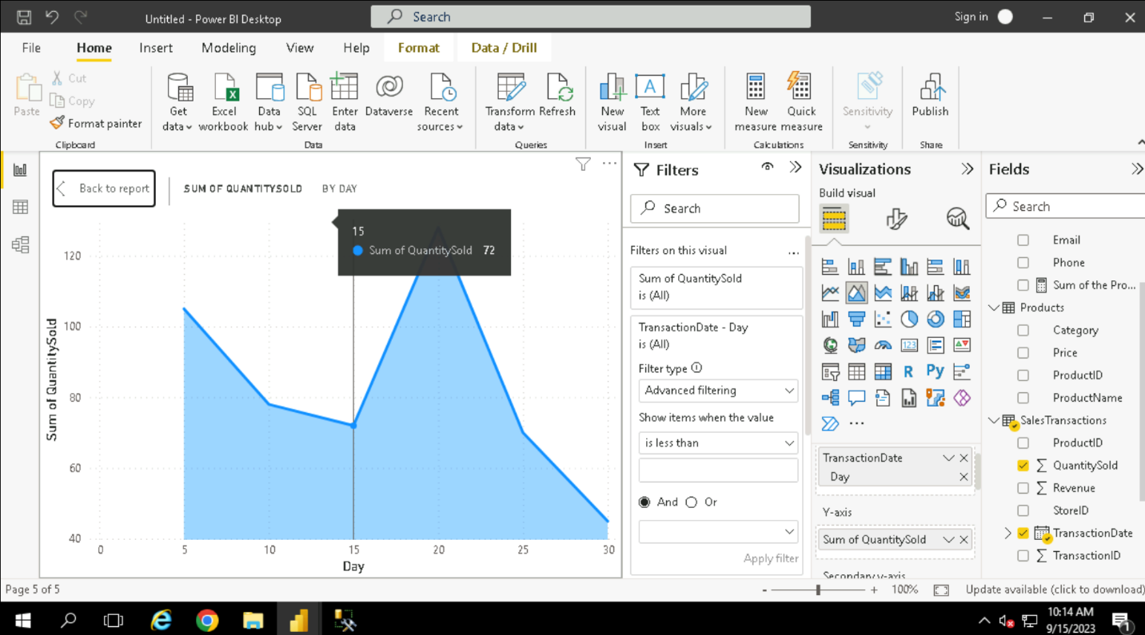

How do sales trends vary by product category on a monthly basis?

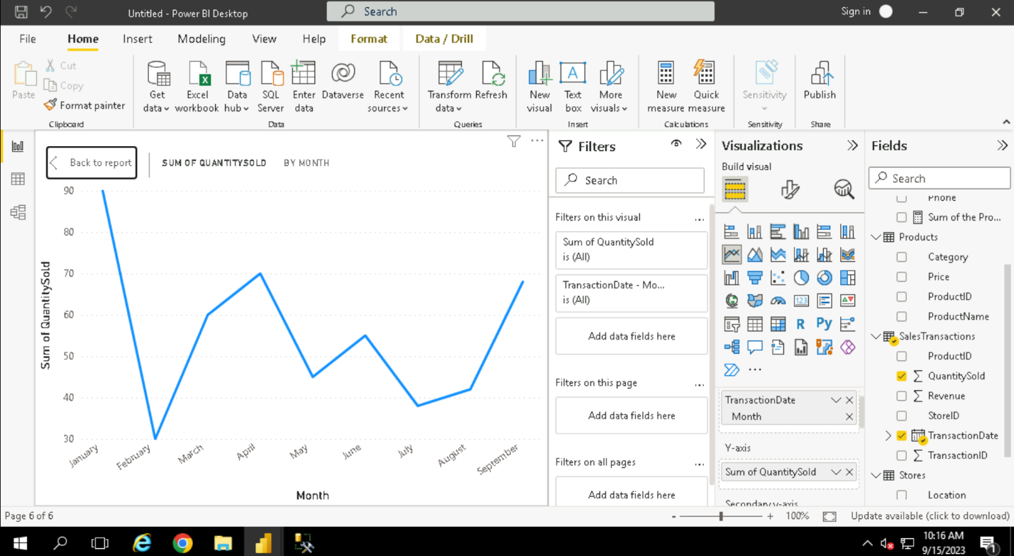

What percentage of products account for 80% of total sales revenue?

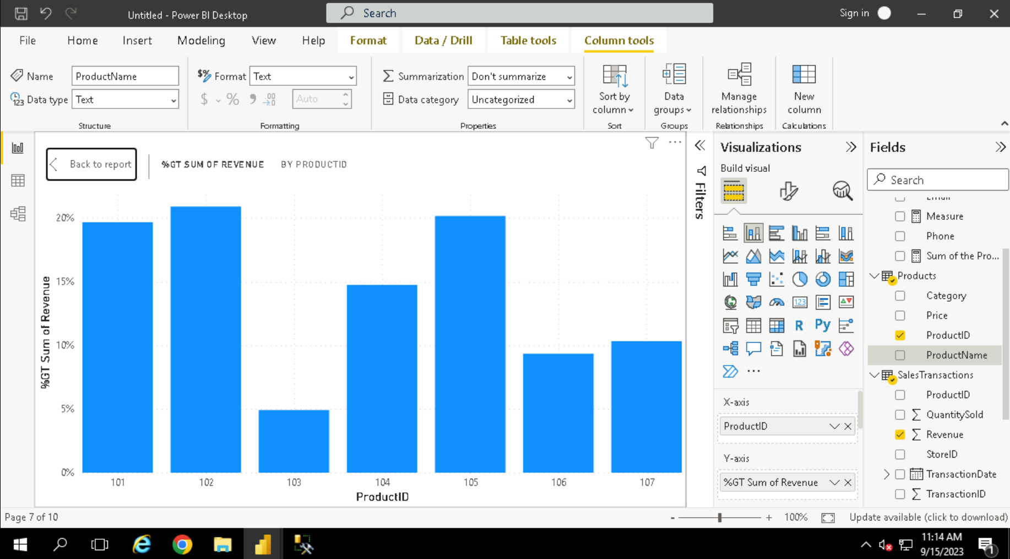

Which product categories perform best at each store location?

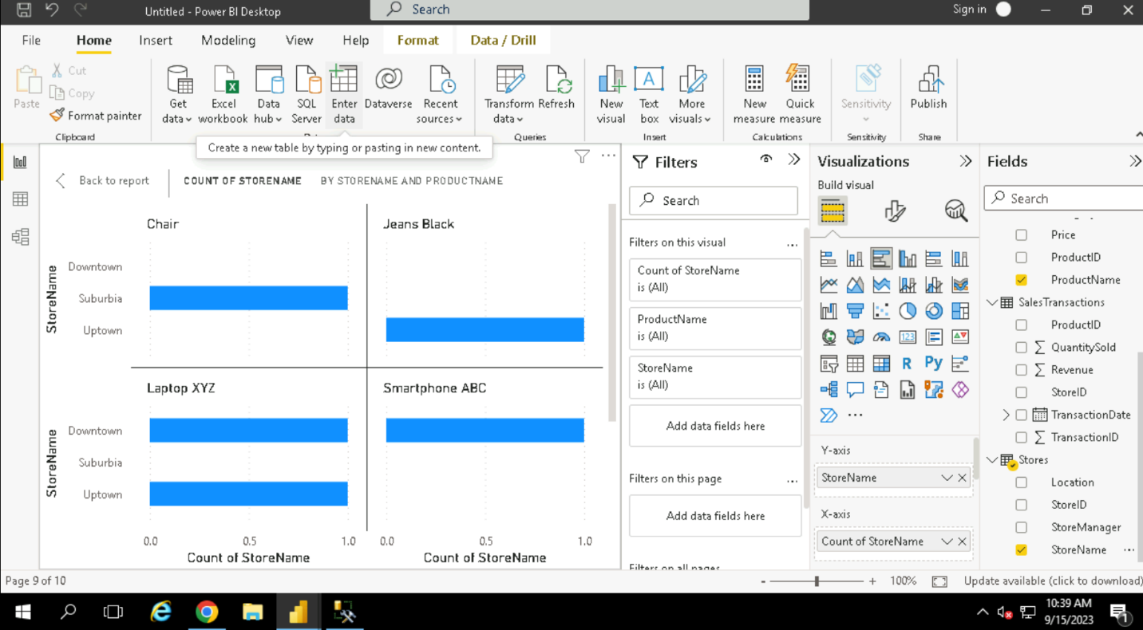

Are there any seasonal patterns or trends in sales for specific products or categories?

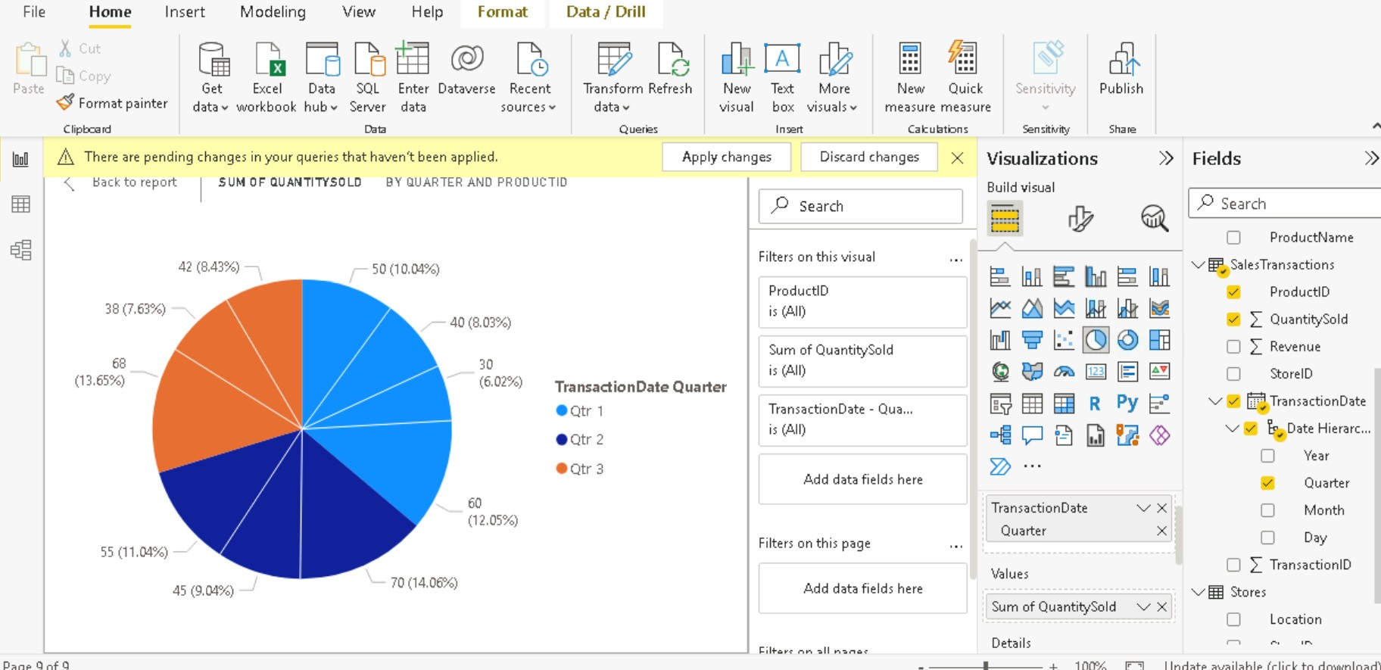

Requirement 5: Data Insights and Recommendations

• Analyze Patterns: Identify patterns and trends in the data, such as seasonality or regional

variations and show it or mark it.

• Generate Insights: Provide actionable insights based on your analysis. For example, suggest

increasing markings efforts for the most profitable product category.

• Create Visual Stories: Use storytelling techniques to communicate your findings effectively in the reports and dashboards

**These are the data insights from the given dataset**

**The sale of quantity of goods in decreasing.**

